CSE3506 Essentials of Data Analytics

Name : Mohan R
Reg. No. : 20MCD1001
Lab Exercise: 1 - Linear Regression Model

Objective: To create and analyse the linear regression model for the dataset mtcars using R programming.
Methods:
- Attach the dataset mtcars in the workspace or create a data frame using mtcars dataset using data.frame function
- Creating linear regression models using the R function lm()
- Display the coefficients of the model
- Display the model summary using summary()
- Interpretation of the model Viz.
  - call
  - Residuals
  - coefficients,
  - standard error
  - t value
  - Pr(>t)
  - Residual standard error
  - R²
  - Adjusted R²
  - F statistics
- Conclusion
Model Summary
Call:
lm(formula = mpg ~ disp, data = df)

Residuals:
Min 1Q Median 3Q Max
-4.8922 -2.2022 -0.9631 1.6272 7.2305

Coefficients:
Estimate Std. Error t value Pr(>|t|)
(Intercept) 29.599855 1.229720 24.070 < 2e-16 ***
disp -0.041215 0.004712 -8.747 9.38e-10 ***
---
Signif. codes: 0 ‘***’ 0.001 ‘**’ 0.01 ‘*’ 0.05 ‘.’ 0.1 ‘ ’ 1

Residual standard error: 3.251 on 30 degrees of freedom
Multiple R-squared: 0.7183, Adjusted R-squared: 0.709
F-statistic: 76.51 on 1 and 30 DF, p-value: 9.38e-10
Call
This is an R feature that shows what function and parameters were used to create the model. In this exercise response variable is ‘mpg’ and predictor variable is ‘disp’ from mtcars data. lm(formula = mpg ~ disp, data = df)
Model Interpretation
  - Residuals
Residuals are essentially the difference between the actual observed response values (y) and the response values that the model predicted (y-hat). The residual errors shows random pattern but we can see that the distribution of the residuals do not appear to be strongly symmetrical. This indicated that the model predicts certain points that fall far away from the actual observed points.
Residuals:
Min 1Q Median 3Q Max
-4.8922 -2.2022 -0.9631 1.6272 7.2305

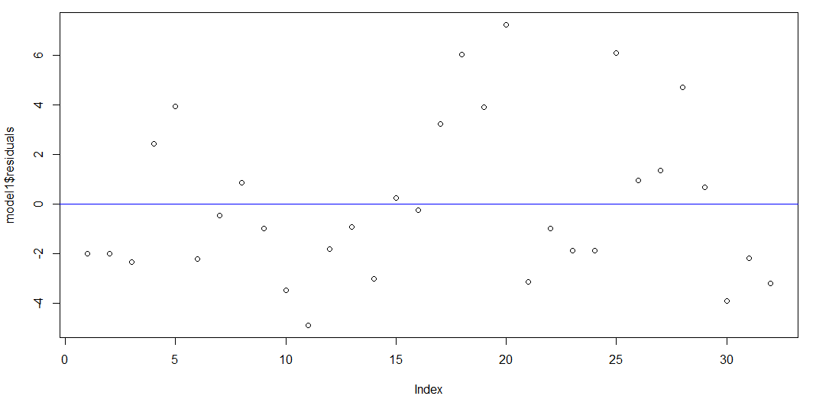
Residual errors

Normality Check
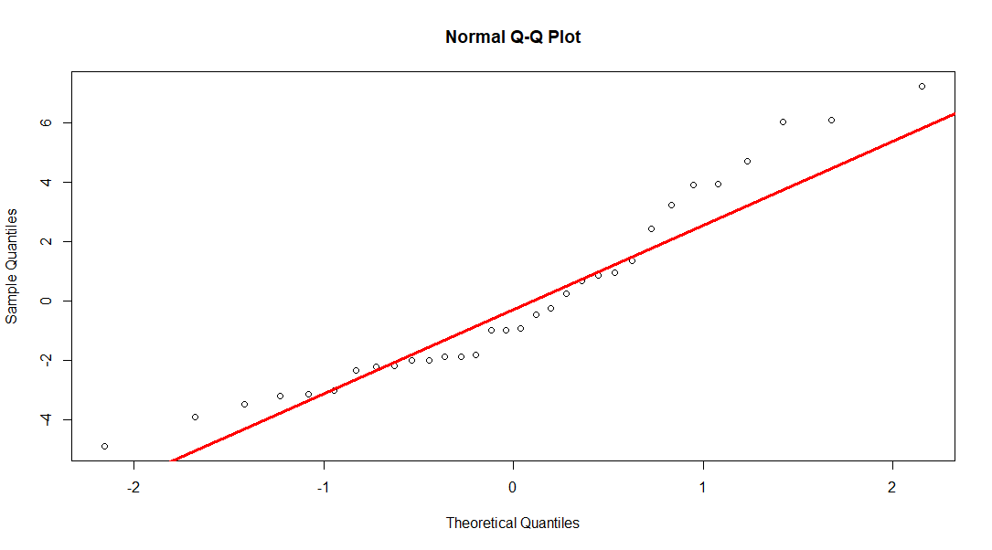
Q-Q plot

Normality Check
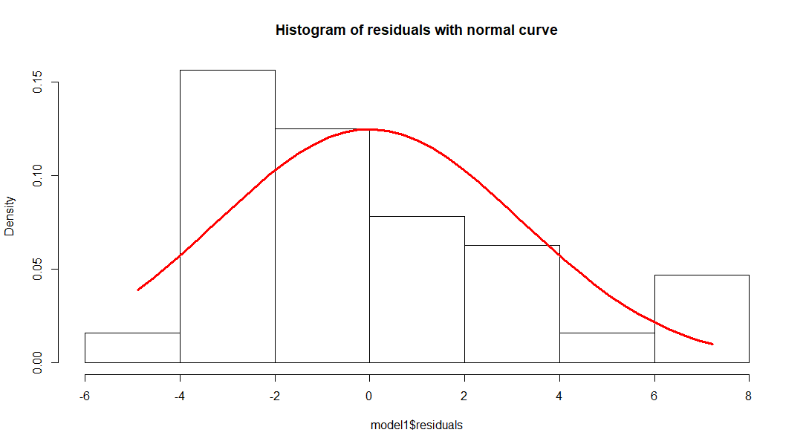
Histogram of residuals with normal curve

  - Coefficients
These are the weights that minimize the sum of the square of the errors. In simple linear regression, the coefficients are two unknown constants that represent the intercept and slope terms in the linear model.
The estimated intercept and slope are
(Intercept) disp
29.59985476 -0.04121512

The coefficient intercept 29.5998 represents mean mpg in our dataset. The coefficients for the slope saying that for every 1 unit increase in displacement of a car, the mpg goes down to -0.04121512 mpg.

  - Standard Errors
The coefficient Standard Error measures the average amount that the coefficient estimates vary from the actual average value of our response variable. So the variation in intercept can be up 1.229720 and variation in mpg will be 0.004712. Lower standard errors are preferable.
  - Coefficients t value
The coefficient t-value is a measure of how many standard deviations our coefficient estimate is far away from 0. We want it to be far away from zero as this would indicate we could reject the null hypothesis - that is, we could declare a relationship between speed and distance exist. In general, t-values are also used to compute p-values.
The t-statistic values 24.070 and -8.747 is calculated by coefficients divided by standard error.
29.599855 / 1.229720
24.0704

-0.041215/0.004712
-8.746817

The t-statistic values 24.070 and -8.747 are relatively far away from zero and are large relative to the standard error, which could indicate a relationship exists.

  - Coefficients Pr(>t)
The Pr(>t) relates to the probability of observing any value equal or larger than t. A small p-value indicates that it is unlikely we will observe a relationship between the predictor (disp) and response (mpg) variables due to chance. Typically, a p-value of 5% or less is a good cut-off point.
- NULL HYPOTHESIS H0 : β1 = 0
- ALTERNATIVE HYPOTHESIS HA : β1 ≠ 0

The p-values < 2e-16 *** and 9.38e-10 *** are very close to zero and the ‘signif. Codes’ associated to each estimate. Three stars (or asterisks) represent a highly significant p-value. Consequently, a small p-value for the intercept and the slope indicates that we can reject the null hypothesis which allows us to conclude that there is a relationship between disp and mpg.

  - Residual standard error
Residual Standard Error is measure of the quality of a linear regression fit. Theoretically, every linear model is assumed to contain an error term ε. Due to the presence of this error term, we are not capable of perfectly predicting our response variable (mpg) from the predictor (disp) one. The Residual Standard Error is the average amount that the response (mpg) will deviate from the true regression line.
The actual mpg can deviate from the true regression line by approximately 3.251 mpg, on average.
The percentage of error in prediction is 3.251 / 29.599855*100 = 10.98%.

  - R²
The R-squared (R2) statistic provides a measure of how well the model is fitting the actual data. It is the ratio of (1-(sum of squared error/sum of squared total))
Multiple R-squared 0.7183 or roughly 72% of the variance found in the response variable (mpg) can be explained by the predictor variable (disp).

  - Adjusted R²
If we add variables no matter if its significant in prediction or not the value of R-squared will increase which the reason Adjusted R-squared is used because if the variable added isn’t significant for the prediction of the model the value of Adjusted R-squared will reduce, it one of the most helpful tools to avoid overfitting of the model.
Adjusted R-squared: 0.709. It is reasonable good.
  - F statistics
F-statistic is a good indicator of whether there is a relationship between our predictor and the response variables. The further the F-statistic is from 1 the better it is. However, how much larger the F-statistic needs to be depends on both the number of data points and the number of predictors.
Generally, when the number of data points is large, an F-statistic that is only a little bit larger than 1 is already sufficient to reject the null hypothesis (H0 : There is no relationship between disp and mpg). The reverse is true as if the number of data points is small, a large F-statistic is required to be able to ascertain that there may be a relationship between predictor and response variables. In our example the F-statistic is 76.51 which is relatively larger than 1 given the size of our data.

Conclusions
The change in one unit in displacement will bring -0. 041215 units to change in mile per gallon.
Since the p value of the coefficients are less than 0,05, both the estimated coefficients β0 and β1 are significant.
The Multiple R-squared: 0.7183 and Adjusted R-squared: 0.709 show the goodness of fit. It is reasonably high and hence acceptable for this study.
Since, mile per gallon is not only depended displacement, other predictors mentioned in the mtcars dataset also may contribute for better model. So, applying multi linear regression will minimize the residual standard error and provide optimal fit.

